Experiment - 7

Aim :
Develop radix-2 butterfly FFT (Decimation in Time) algorithm for the computation of N-point DFT.

Theory:
Getting to Know the FFT
What is the FFT? FFT = Fast Fourier Transform. The FFT is a faster version of the Discrete Fourier Transform (DFT). The FFT utilizes some clever algorithms to do the same thing as the DTF, but in much less time.
Ok, but what is the DFT?
The DFT is extremely important in the area of frequency (spectrum)analysis because it takes a discrete signal in the time domain and transforms that signal into its discrete frequency domain representation. Without a discrete-time to discrete-frequency transform we would not be able to compute the Fourier transform with a microprocessor or DSP based system. It is the speed and discrete nature of the FFT that allows us to analyze a signal's spectrum with Matlab or in real- time on the SR770

The Laplace transform is used to find a pole/zero representation of a continuous-time signal or system, x(t), in the s-plane. Similarly, The z transform is used to ¯nd a pole/zero representation of a discrete-time signal or system, x[n], in the z-plane.
The continuous-time Fourier transform (CTFT) can be found by evaluating the Laplace trans- form at s = j The discrete-time Fourier transform (DTFT) can be found by evaluating the z transform at z = e-j
Understanding the DFT
How does the discrete Fourier transform relate to the other transforms? First of all, the DFT is NOT the same as the DTFT. Both start with a discrete-time signal, but the DFT produces a discrete frequency domain representation while the DTFT is continuous in the frequency domain. These two transforms have much in common, however. It is therefore helpful to have a basic understanding of the properties of the DTFT.
Periodicity: The DTFT, X(e-j ), is periodic. One period extends from f = 0 to fs, where
fs is the sampling frequency. Taking advantage of this redundancy, The DFT is only defined in the region between 0 and fs.

Symmetry: When the region between 0 and fs is examined, it can be seen that there is even symmetry around the center point, 0.5fs, the Nyquist frequency. This symmetry adds redundant information. Figure 1 shows the DFT (implemented with Matlab's FFT function) of a cosine with a frequency one tenth the sampling frequency. Note that the data between 0.5fs and fs is a mirror image of the data between 0 and 0.5fs

IN LAB EXERCISE

Write your own MATLAB function to compute DFT using FFT DIT, FFT DIF, FFT (in built function)

%decimation in time
x = input('Enter the input sequence :');
l = length(x);
k = 0;
while((2^k)<1)
k = k+1;
end
x1 = [x zeros(1,(2^k)-1)];
n = length(x1);
y = zeros(1,n);
j = 1;
for k = 1:2:n;
xe(j) = x1(k);
j=j+1;
end
j = 1;
for k = 2:2:n;
xo(j) = x1(k);
j=j+1;
end
for k=1:1:n;
for j=1:1:(n/2);
y(k) = y(k) + xe(j)*exp(-4*pi*1i*(j-1)*(k-1)/n) + exp(-2*pi*1i*(k-1)/n)*xo(j)*exp(-4*pi*1i*(j-1)*(k-1)/n);
end
end
axis tight
subplot(2,1,1)
stem(x)
xlabel("Samples [n]")
ylabel('Amplitude [n]')
title('input sequence x[n] 22102071')
subplot(2,1,2)
stem(abs(y))
xlabel("Freq index [k]")
ylabel('Magnitude |X[k]|')
title('DFT magnitude of x[n] 22102071')

%Decimation in frequency
X = input('Enter the input sequence :');
l = length(X);
k = 0;
while((2^k)<l)
k = k+1;
end
X11 = [X zeros(1,(2^k)-l)];
n = length(X11);
Y = zeros(1,n);
X1 = zeros(1,n/2);
X2 = zeros(1,n/2);

for j = 1:2:n
X1((j+1)/2) = X11(j);
end

for j = 2:2:n
X2(j/2) = X11(j);
end

for k = 1:n
for j = 1:n/2
Y(k) = Y(k) + (X1(j) + exp(-1i*pi*(k-1))*X2(j))*exp(-2i*pi*(j-1)*(k-1)/n); % Corrected formula
end
end

subplot(2,1,1)
stem(X)
xlabel("Samples [n]")
ylabel('Amplitude [n]')
title('input sequence X[n] 22102071')

subplot(2,1,2)
stem(abs(Y))
xlabel("Freq index [k]")
ylabel('Magnitude |X[k]|')
title('DFT magnitude of X[n] 22102071')

%using inbuilt function
x=input('Enter the input sequence: ');
N=input('Enter the length of FFT: ');
X=fft(x,n);
axis tight
subplot(2,1,1)
stem(x)
xlabel('Samples [n]')
ylabel('Amplitude x[n]')
title('Input sequence 22102071')
subplot(2,1,2)
stem(abs(y))
xlabel('Freq index [k]')
ylabel('Magnitude X[k]')
title('DFT magnitude of x[n] 22102071')

output:

1.
Enter the input sequence :
[ 6 7 8 9 6 9]

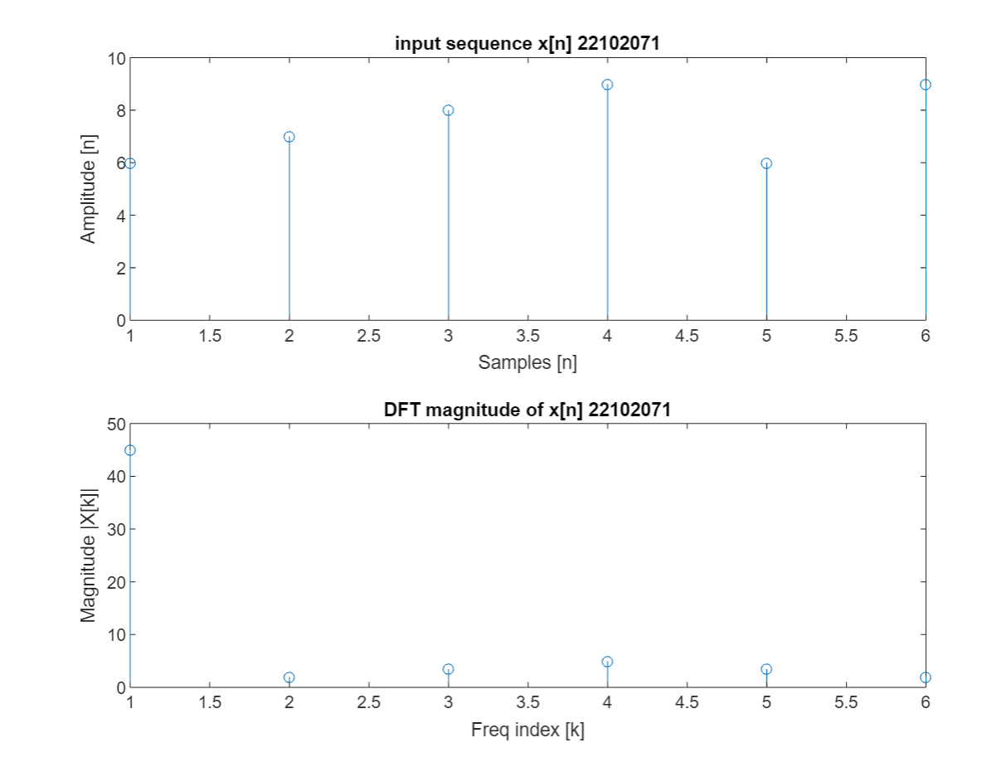

2.
Enter the input sequence :
[ 3 5 7 3 1 3]

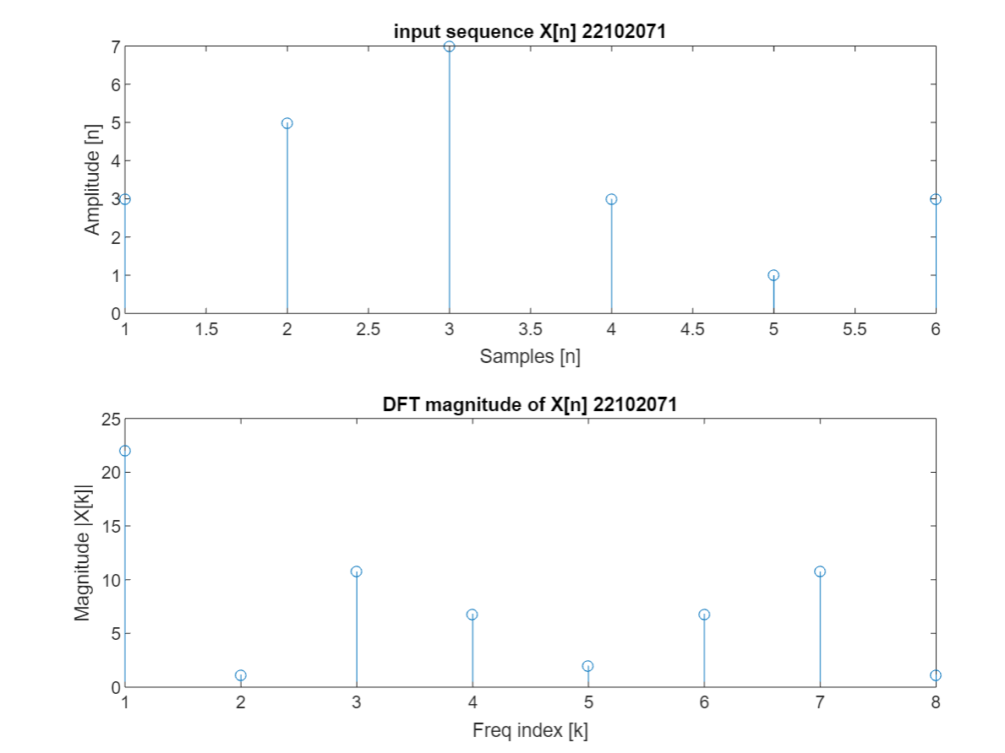

3.
Enter the input sequence:
[ 12 3 4 56 7]
Enter the length of FFT:
5

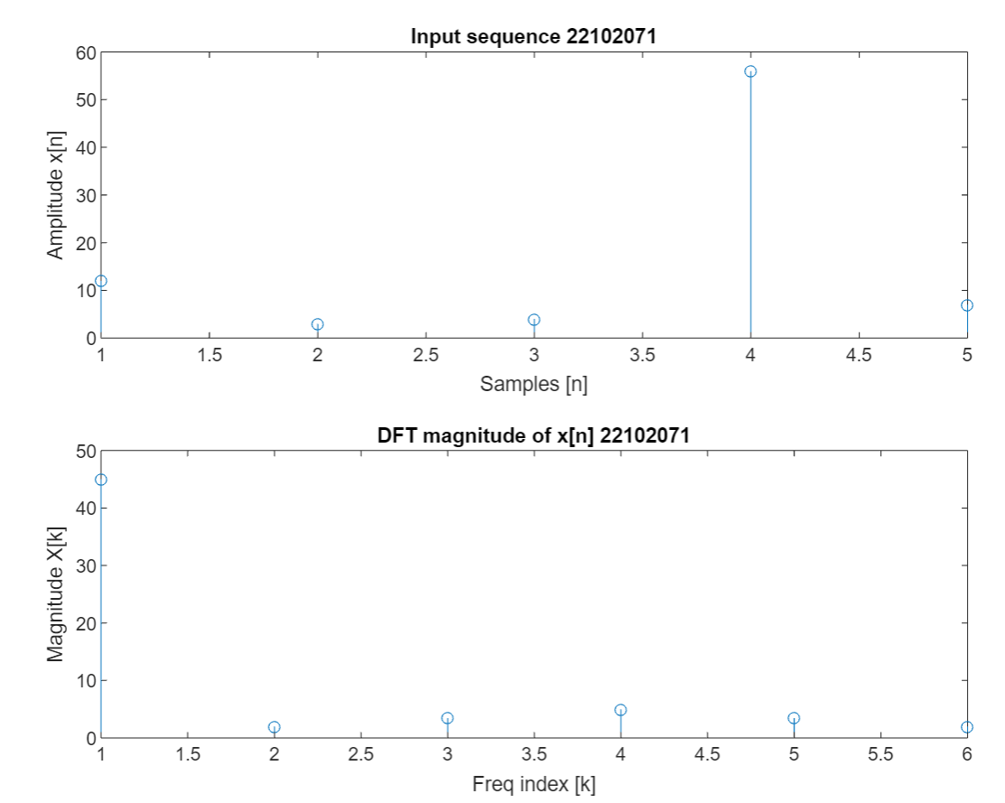

POSTLAB EXERCISE : 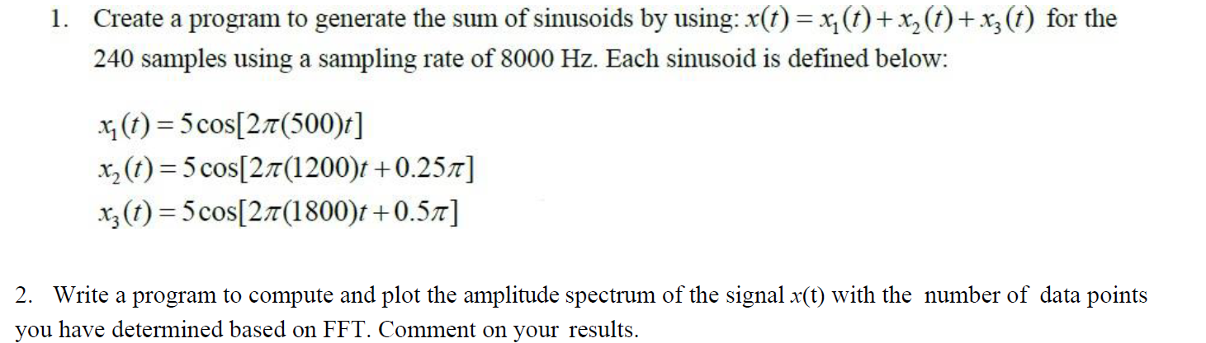
no_of_samples = 240;
duration = 1;
t = linspace(0, duration, no_of_samples);
x = 5*cos(2 * pi * 500 * t) + 5*cos(2*pi*1200*t + 0.25*pi) + 5*cos(2 * pi * 1800 * t + 0.5*pi);

x = [x,zeros(1,256-240)];
dit_fft(x,256,8000);
disp('DFT using the in built fft function = ')
disp(fft(x));
disp('DFT using user defined dft function = ')
disp(mydft(x,256))

function [X,W] = dit_fft(x,N,Fs)
if mod(log2(N), 1) ~= 0
error('The number of points must be a power of 2.');
end
X = x(bitrevorder(1:N));
for stage = 1:log2(N)
halfNumPoints = 2^(stage - 1);
fullNumPoints = 2^stage;
twiddleFactorBase = exp(-2 * pi * 1i / fullNumPoints);
for index = 1:halfNumPoints
twiddleFactor = twiddleFactorBase^(index - 1);
for evenIndex = index:fullNumPoints:N
oddIndex = evenIndex + halfNumPoints;
temp = X(evenIndex) + twiddleFactor * X(oddIndex);
X(oddIndex) = X(evenIndex) - twiddleFactor * X(oddIndex);
X(evenIndex) = temp;
end
end
end
df = Fs / N;
W = (0:N-1) * df;
disp('DFT using DIT-FFT = ')
disp(X)
disp('Digital frequencies = ')
disp(W)
figure(1);
subplot(2,1,1)
stem(abs(W),X)
title('Gaurav Saxena 22102071')
xlabel('Digital Frequencies')
ylabel('Amplitude')
subplot(2,1,2)
stem(W,angle(X))
title('Gaurav Saxena 22102071')
xlabel('Digital Frequencies')
ylabel('Amplitude')
end
function order = bitrevorder(indices)
numPoints = length(indices);
M = log2(numPoints);
order = zeros(1, numPoints);
for k = 1:numPoints
reversedIndex = 0;
for n = 1:M
reversedIndex = bitor(reversedIndex, bitshift(bitget(k - 1, n), M - n));
end
order(k) = reversedIndex + 1;
end
end

Output:

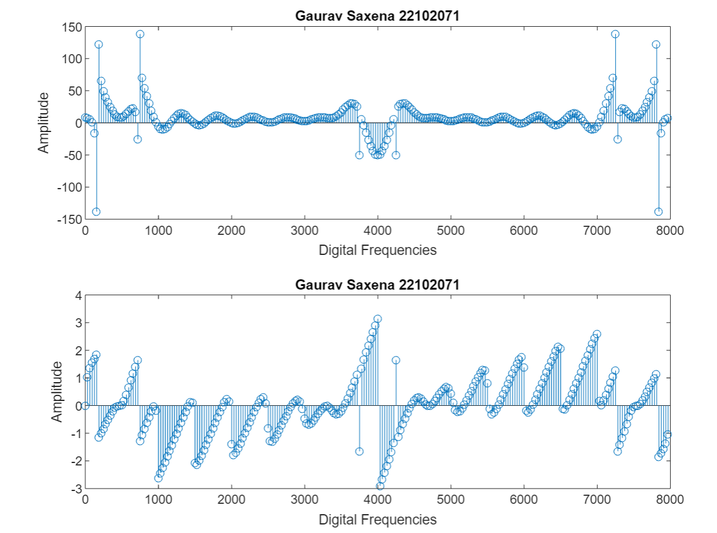

LEARNING OUTCOME:
- Understanding the process of DFT using FFT DIT, FFT DIF, FFT (in built function).
- Learning the code required to calculate the above

